# Deploying ReactJS app to S3

## Creating the deployment files

Create the deployment files for the ReactJS app by typing the command “**npm run build**” in the project terminal in Visual Studio Code.

## Login to AWS S3

Login to AWS Console using your credentials for NYP Open House 2025 – [here](https://us-east-2.signin.aws.amazon.com/oauth?client_id=arn%3Aaws%3Asignin%3A%3A%3Aconsole%2Fcanvas&code_challenge=dKDT_QrrJTIYGwx0RzooI2xR6iV6vVVYIpj0sSuHrqc&code_challenge_method=SHA-256&response_type=code&redirect_uri=https%3A%2F%2Fconsole.aws.amazon.com%2Fconsole%2Fhome%3FhashArgs%3D%2523%26isauthcode%3Dtrue%26oauthStart%3D1728985437406%26state%3DhashArgsFromTB_us-east-2_92bdb09a75d0c837).

## Navigate to AWS S3

Navigate to AWS s3 using the Search Bar to search for S3 or [here](https://ap-southeast-1.console.aws.amazon.com/s3/home?region=ap-southeast-1).

## Select the S3 Bucket to update

Click on openhouse2025-reactjs-prod bucket.

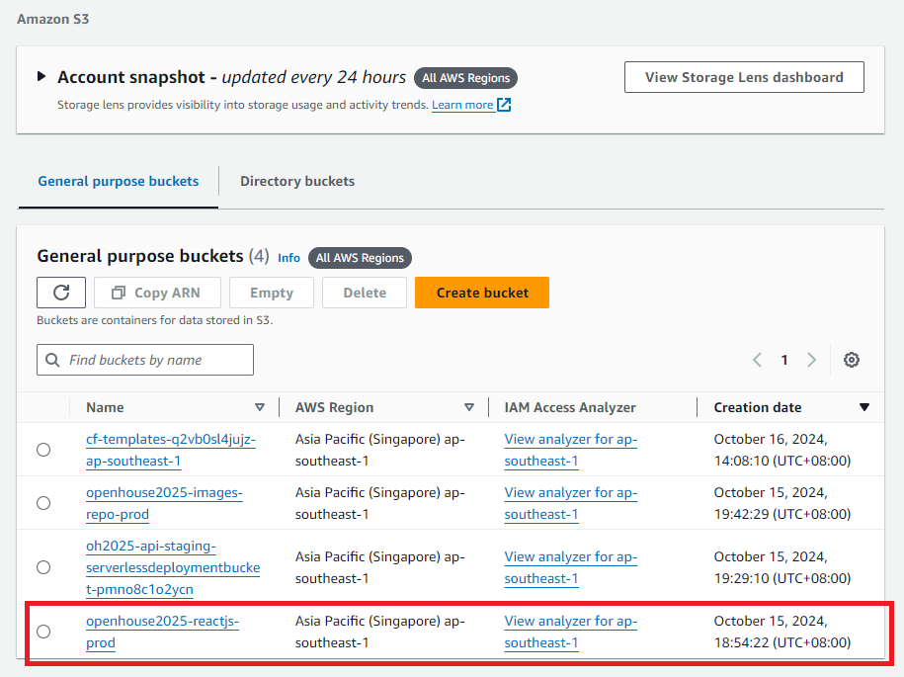

## Delete all the existing files in S3 Bucket

Select all the files in the S3 bucket and delete them away.

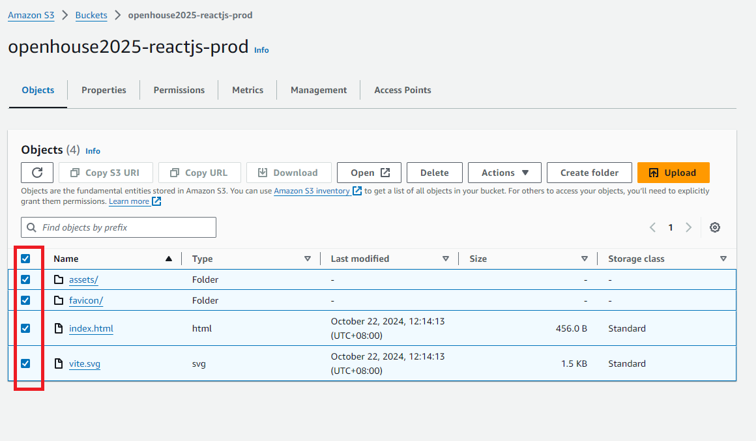

Confirm when prompted.

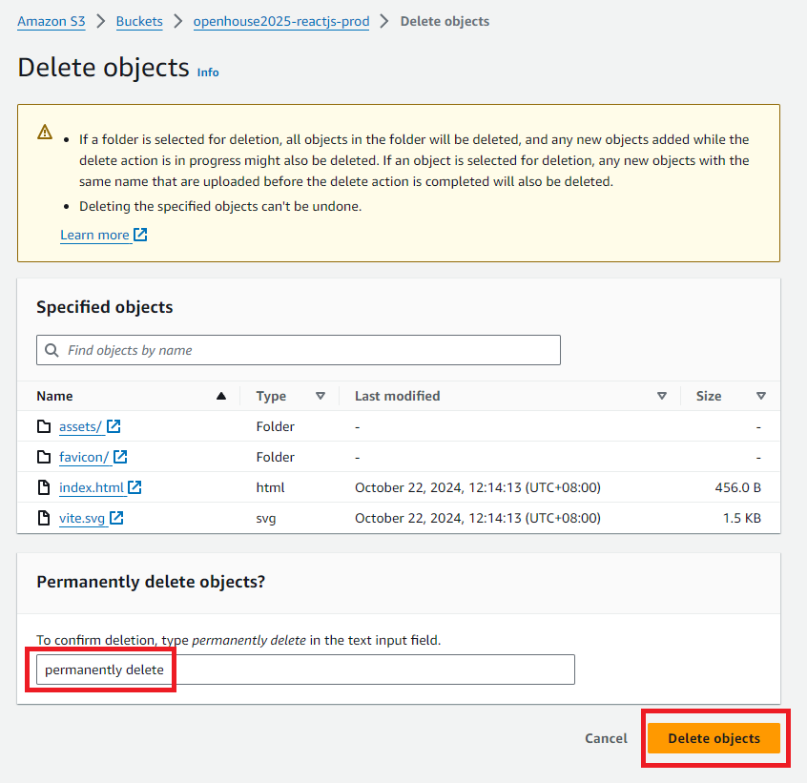

Click close when done.

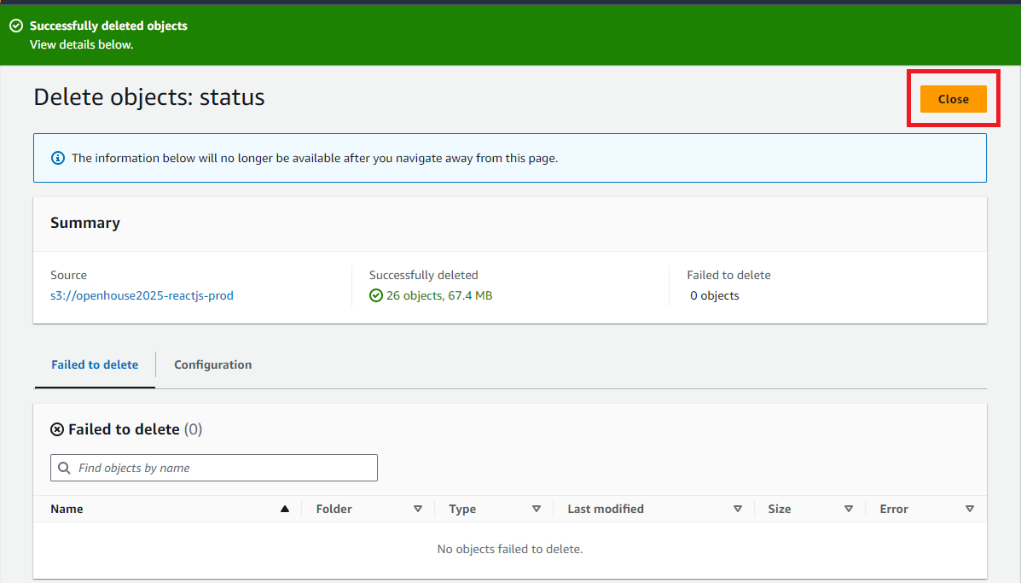

## Upload the newly generated project files

Upload the files generated in ***Step 1) Creating the deployment files*** which can be found in the dist folder in the project

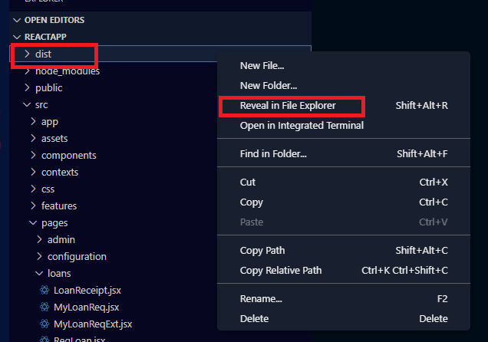

Drag and drop all the files into the S3 Bucket

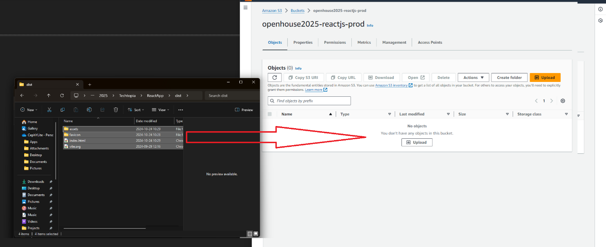

## Navigate to AWS Cloudfront

Navigate to AWS Cloudfront by using the search bar to search for “cf”.

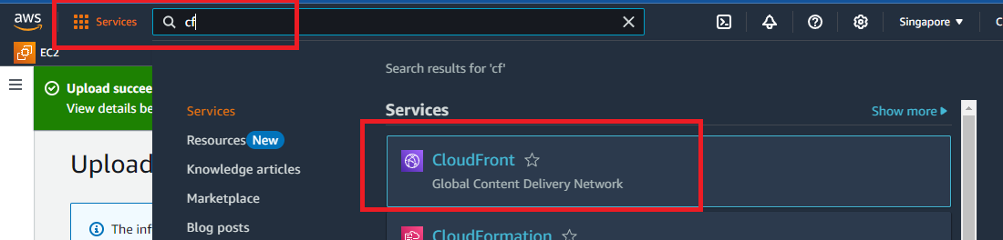

## Click on the Cloudfront Distribution for the Project

Click on the distribution for the Open House 2025 ReactJS Project by checking the domain name dcekdv14f8j3k.cloudfront.net

## Click on Invalidations tab

Click on the Invalidations tab.

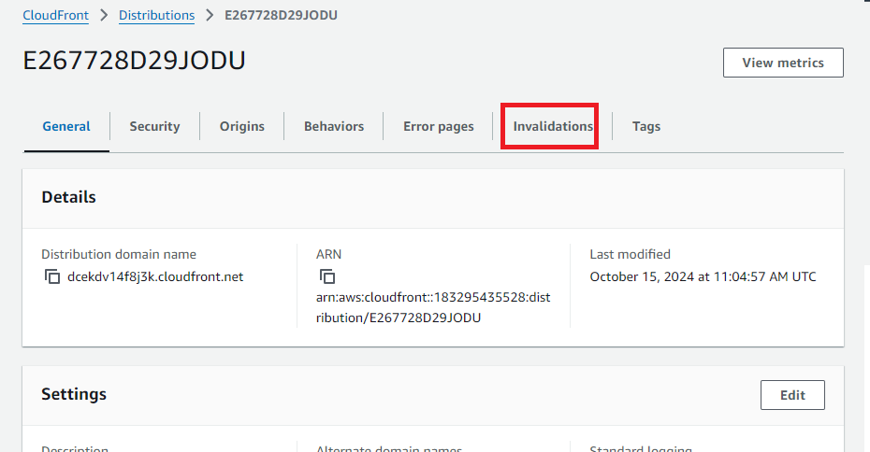

## Create a Invalidation job

Either copy a invalidation job either by copy from any of the existing one or create a new one and type in **/\***.

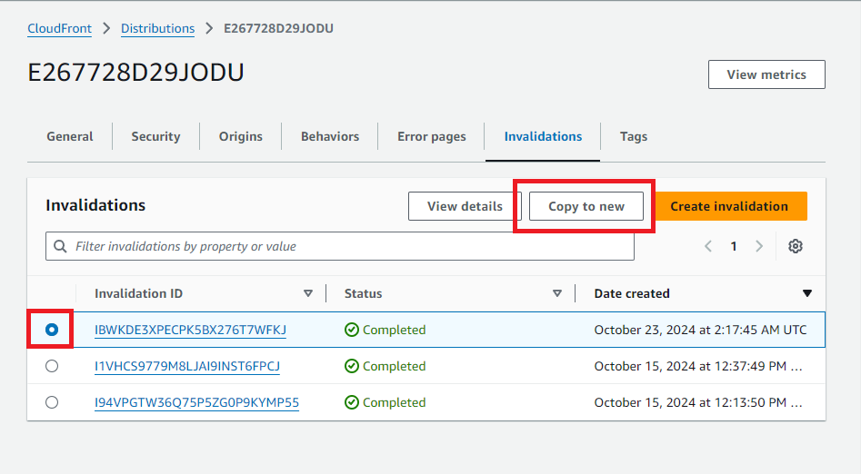

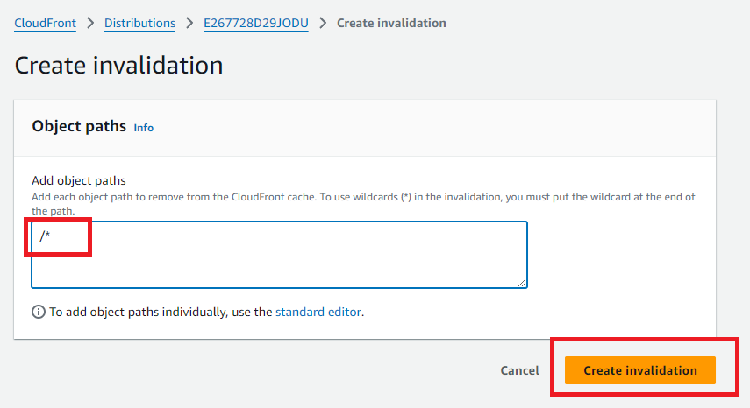

## Check the deployment

Once the invalidation is Complete, proceed to the [project URL](dcekdv14f8j3k.cloudfront.net) to verify the deployment.

